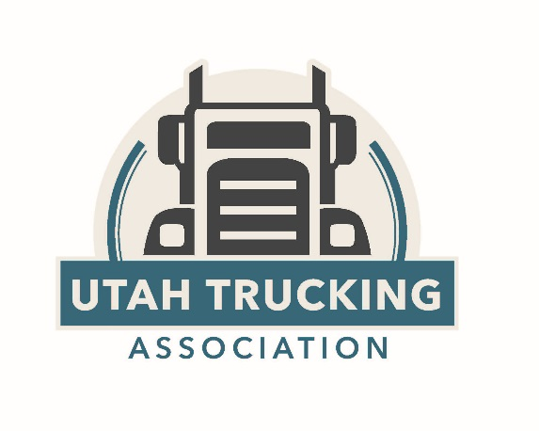
Utah Trucking Association
Allied Member Benefits & Discounts

Utah Trucking Association’s number one priority is its members. Utah Trucking Association is committed to providing services, products, education, and opportunities that offer its members the highest benefit. We encourage well-trained and safe drivers, help to ensure running profitable companies, and desire to have our members be responsible citizens in the communities of Utah and the nation. We provide our members with trainings, government and media representation, discounted goods, services, networking and marketing opportunities and much more.
Allied or Supplier members of Utah Trucking Association are entitled to a variety of member benefits:

Networking Opportunities:

We provide many opportunities to network with other trucking company executives and allied members such as: The Annual Utah Trucking Association Convention & Expo, ATV jamborees, road rallies, monthly lunches at various locations throughout the state and many other events. These provide an educational forum and collaborative environment where we can all learn from one another. To find more information about the various events we host, visit UtahTrucking.com

Involvement Opportunities:
- Monthly Regional Meetings: Utah Trucking Association meets monthly with its members at regional meetings throughout the state such as the: Northern Utah meeting in Ogden, the Southern Utah meeting in St. George, the Basin Utah meeting in Vernal, the Central Utah meeting in Price and the Safety Management Council in Salt Lake. Allied members may attend any of these meetings for networking purposes and also have the opportunity to sponsor and present at these luncheons to an average of 30+ attendees.
- Committees: Utah Trucking Association has several committees which members may be involved in. They include: SuperTech Challenge Planning Committee, Legislative Committee, Image & Safety Committee, and Convention Planning Committee. If you would like to be involved in any of these committees, please inform one of Utah Trucking Association staff members at 801-973-9370. We would love to have you involved!
- Annual Management Conference & Trucking Expo: This 3- day expo is held every year in St. George, Utah and typically has an attendance of 500+ people each year. Members can sponsor, advertise, manage a booth, host an educational break-out session and network. This is a great opportunity to meet with many key leaders in the transportation industry at one time. To find out more about this convention please visit our website: UtahTrucking.com
- Host a Seminar: If you or your company feel you are leading experts in your field and could host an educational seminar on your subject, contact Jon Boyer with your proposal at 801-973-9370 or jon@utahtrucking.com. (promotions or advertisements not permitted.)

Discounts:
- Workers Compensation Fund: Good standing membership in the Utah Trucking Association qualifies for a 5% discount on their premiums. Contact your WCF representative for more info.
- Crystal Inn Hotel and Suites: Members have a great negotiated special rate at various locations. Contact Cindy Hornsby at cindyh@crystalinns.com or 801-736-2004. St. George contact: John Olsen, johno@dixiehs.com, 877-688-7177.
- Utah Trucking Association 401k Plan: Contact Corby Dall at 801-631-1988 or corby@401kaim.com

Advertising Opportunities:
      - “Truckin’ Hot News” Newsletter: this popular newsletter is available to all who join the association.
      - Utah Trucking Association’s Magazine: A quarterly publication sent to over 1700 people including all our members, legislators, and transportation industry affiliates. We have various sizes of ads available. Find our latest edition at utahtrucking.com.
      - Utah Trucking Association’s Website: Advertising opportunities on our organizational website: utahtrucking.com
      - Membership List: As a member of the Utah Trucking Association, you get access to our 600+ membership contact list full of emails, phone numbers, and points of contact for various companies.
      - Social Media Platforms: We would love to highlight your company events, accomplishments, and membership free of charge on our various social media sites such as Facebook, Twitter and LinkedIn.

Publication Opportunities:

We offer the opportunity for members to publish articles or editorials in our magazine, Utah Trucking, of their authorship, to be distributed four times a year to the magazines 1500 hard copy readers and countless electronic viewers. These articles must be educational and contain accurate and relevant information to the transportation industry or business at large. Articles may vary from 300-700 words. For more information about submitting an article or editorial to the magazine, contact Jon Boyer at jon@utahtrucking.com. (promotions or advertisements not permitted.)

Government Relations:

The Utah Trucking Association’s supplied ”Bill Tracker” lets members know what bills are being debated that affect the industry and allows them to voice their opinion, helping the Association represent them in the best way possible. We also have maintained great relations with UDOT officials, the Utah Highway Patrol, our federal representatives, the Governor’s office and other key policy makers.
If you have any other questions regarding the Utah Trucking Association and we can do for you, please do not hesitate to contact us as we would be happy to assist.

The Utah Trucking Association exists to benefit its members. If there is ever anything at all that we can do for you please don’t hesitate to reach out to anyone at our office:

Office: 801.973.9370 | Fax: 801.973.8515

Rick Clasby, Executive Director
rick@utahtrucking.com | 801.243.6521

Terry Smith, Safety Director
terry@utahtrucking.com | 801.560.1687

Jon Boyer, Communications & Administration Director
jon@utahtrucking.com | 801.361.6756

